In this lab, you will experience what its like to be a backend engineer working for an e-commerce company. The company is gearing up for the Thanksgiving sale that is the biggest annual shopping event for the company. Your job is to implement a decoupled backend architecture that is able to handle the spike in traffic for the duration of the sale and ensure that none of the customer orders are lost.

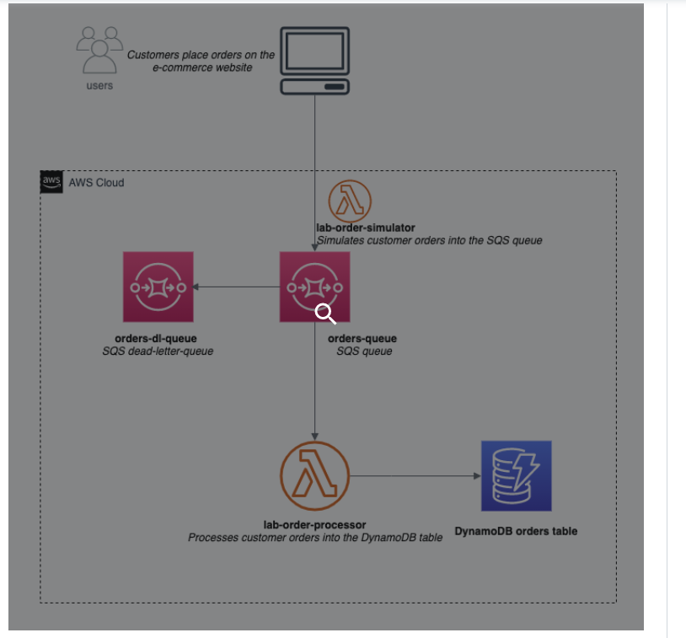

**Create SQS standard queue to send, store, and receive order messages**

* [lab4-mySQS-order](https://us-east-1.console.aws.amazon.com/sqs/v2/home?region=us-east-1#/queues/https%3A%2F%2Fsqs.us-east-1.amazonaws.com%2F944367331262%2Flab4-mySQS-order) [[lab4-mySQS-Order-DLQ](https://us-east-1.console.aws.amazon.com/sqs/v2/home?region=us-east-1#/queues/https%3A%2F%2Fsqs.us-east-1.amazonaws.com%2F944367331262%2Flab4-mySQS-Order-DLQ)](https://us-east-1.console.aws.amazon.com/sqs/v2/home?region=us-east-1#/queues/https%3A%2F%2Fsqs.us-east-1.amazonaws.com%2F944367331262%2Flab4-SQS-DLQ-Order)

### Create DynamoDB Table to capture the processed order data

[lab4_order](https://us-east-1.console.aws.amazon.com/dynamodbv2/home?region=us-east-1#table?name=lab4_order)

### 

### Create a Lambda function to simulate orders into the SQS queue

### 

### Create a Lambda function to process orders into DynamoDB table

### Rule:

### 